**LOCAL GUIDE**

**A PROJECT REPORT**

**for**

**Mini Project-I (ID102B)**

**Session (2024-25)**

**Submitted by**

Ashwani Kumar Katiyar (202410116100044)

Anup Kumar Mahto (202410116100038)

Bishop Tyagi (202410116100050)

**Submitted in partial fulfilment of the**

**Requirements for the Degree of**

**MASTER OF COMPUTER APPLICATION**

**Under the Supervision of**

**Ms. Divya Singhal**

### Assistant Professor



**Submitted to**

**Department Of Computer Applications**

**KIET Group of Institutions, Ghaziabad**

**Uttar Pradesh-201206**

**(december- 2024)**

**CERTIFICATE**

Certified that Ashwani Kumar Katiyar (202410116100044), Anup Kumar Mahto (202410116100038), Bishop Tyagi (202410116100050) has/ have carried out the project work having “**Local Guide**” (**Mini Project-I, ID102B**) for **Master of Computer Application** from Dr. A.P.J. Abdul Kalam Technical University (AKTU**)** (formerly UPTU), Lucknow under my supervision. The project report embodies original work, and studies are carried out by the student himself/herself and the contents of the project report do not form the basis for the award of any other degree to the candidate or to anybody else from this or any other University/Institution.

**Ms. Divya Singhal Dr. Arun Kr. Tripathi**

**Assistant Professor Dean**

**Department of Computer Applications Department of Computer Applications**

**KIET Group of Institutions, Ghaziabad KIET Group of Institutions, Ghaziabad**

**Local Guide**

Ashwani Kumar Katiyar , Anup Kumar Mahto , Bishop Tyagi

**ABSTRACT**

The Local Guide is an innovative web application designed to connect customers with local businesses, providing comprehensive information about grocery stores, medical shops, gyms, salons, hardware stores, and electronics shops in their area. Built using frontend including HTML, CSS, JavaScript and backend, the platform offers an intuitive interface for users to explore, compare, and choose shops based on their preferences. Each shop listed on the website displays essential details, including its name, image, address, ratings, and reviews. Additionally, individual pages for each shop showcase their product offerings with descriptions, prices, and availability. This allows users to make informed decisions about which shop provides the best value for their needs. The platform aims to empower users by simplifying the process of finding affordable and convenient shopping options while promoting local businesses by enhancing their visibility. The website also includes features like category-based filtering, search functionality, and product price comparison, making it user-friendly and efficient. Future enhancements may include user accounts for personalized recommendations, integration of location-based services for real-time suggestions, and e-commerce capabilities for online orders and payments. By bridging the gap between consumers and local businesses, Local Guide fosters a thriving local economy and improves the shopping experience. This project is an ideal blend of practicality and innovation, offering a valuable resource for both residents and small business owners in the community.

**ACKNOWLEDGEMENTS**

Success in life is never attained single-handedly. My deepest gratitude goes to my project supervisor, **Ms. Divya Singhal** for her guidance, help, and encouragement throughout my project work. Their enlightening ideas, comments, and suggestions.

Words are not enough to express my gratitude to Dr. Arun Kumar Tripathi, Professor and Dean, Department of Computer Applications, for his insightful comments and administrative help on various occasions.

Fortunately, I have many understanding friends, who have helped me a lot on many critical conditions.

Finally, my sincere thanks go to my family members and all those who have directly and indirectly provided me with moral support and other kind of help. Without their support, completion of this work would not have been possible in time. They keep my life filled with enjoyment and happiness.

Ashwani Kumar Katiyar

Anup Kumar Mahto

Bishop Tyagi

**TABLE OF CONTENTS**

Certificate ii

Abstract iii

Acknowledgements iv

Table of Contents v

1. Introduction 6 - 9
   1. Description about website
   2. Key feature of shop 8
2. Literature Review 10 -11
3. Project Objective 12 -13
4. Hardware and Software Requirements 14 -15
5. Project Flow 16 -21

1. Project Outcome 22 - 30
2. Reference 31

**Chapter 1**

**INTRODUCTION**

In the modern world, the need for quick access to reliable and well-organized information has never been greater. As consumers, we often find ourselves spending valuable time and effort researching local businesses to identify the best options that meet our requirements. Whether it's finding a grocery store with competitive pricing, a well-rated salon, or a hardware shop with the right tools, the process can be overwhelming. Recognizing this challenge, the Local Guide project was developed as a web-based solution to centralize information about local businesses, making it easily accessible to users.

**OVERVIEW:**

The Local Guide is an innovative platform designed to connect consumers with shops and services in their local area. The website serves as a directory for various types of businesses, including grocery stores, medical shops, gyms, salons, hardware stores, and electronics shops. Each shop is listed with comprehensive details such as its name, image, address, contact information, and user ratings. Businesses can also display their product catalogs with descriptions, prices, and availability, allowing users to compare offerings from multiple shops conveniently.

Developed using HTML, CSS, and JavaScript, the platform offers an interactive and responsive interface for a seamless user experience. A minimal backend supports the storage and retrieval of shop and product data, ensuring the website runs smoothly and efficiently. The platform’s design prioritizes simplicity and ease of use, catering to a wide audience, from tech-savvy users to those with basic internet skills.

The Local Guide serves two primary purposes. For customers, it acts as a one-stop solution to explore shops, compare prices, and make informed decisions about where to shop. By providing transparency in pricing and reviews, the platform enables users to save time and money. For businesses, the Local Guide offers a digital presence, increasing visibility and attracting potential customers. This is especially beneficial for small and medium-sized businesses aiming to compete in a saturated market.

In addition to its immediate benefits, the Local Guide has the potential to foster a more competitive local marketplace, leading to improved pricing and services. Future enhancements such as user accounts, personalized recommendations, location-based services, and e-commerce capabilities will further expand its functionality and user appeal.

By bridging the gap between local businesses and customers, the Local Guide contributes to a thriving local economy while improving the shopping experience for the community. It represents a practical, innovative, and scalable solution to a common challenge faced by modern consumers.

**1.1 Description about website:**

The homepage of the local guide is designed to provide users with seamless navigation through six primary categories: **Grocery**, **Hardware**, **Salon**, **Gym**, **Electronics**, and **Medical**. This intuitive interface serves as the starting point for users to explore a wide range of local shops and services based on their specific needs.

Each category is represented with visually appealing icons or images, ensuring an engaging and user-friendly experience. Upon selecting a category, users are redirected to a dedicated page that displays a list of businesses under that category. For example, choosing the **Grocery** category opens a page showcasing a list of grocery stores, complete with essential details such as:

* **Shop Name**: To identify the business easily.
* **Photo of the Shop**: Providing a visual representation to help users recognize the shop.
* **Location**: Displaying the shop's address or an integrated map view for easy navigation.

The category-specific pages are designed for efficiency, enabling users to browse shops quickly and make informed decisions. Each shop listing may also include options to view additional details like contact information, product availability, ratings, and reviews.

Upon selecting a category, users are directed to a dedicated page displaying shop details such as the **shop name**, **photo**, and **location**. This organized layout helps users quickly identify and locate businesses that meet their needs. The platform is designed to streamline the shopping experience by providing essential information at a glance, saving time and effort for users.

This organized structure simplifies the process of finding local businesses, reduces the time spent searching for services, and enhances the overall shopping experience. The platform's responsive design ensures accessibility across devices, making it a convenient tool for users at home or on the go

This website aims to bridge the gap between consumers and local businesses, promoting a smarter, faster, and more transparent way to shop.

When a user selects a specific shop from the category page, a dedicated shop details page opens. This page is thoughtfully designed to give users a comprehensive view of the shop and its offerings.

**1.2 Key features of the shop details page include:**

1. **Shop Image**: A clear and high-quality image of the shop is displayed, helping users visually identify the business.
2. **Shop Location**: The shop's address is prominently shown, making it easy for users to locate it.
3. **Interactive Map Integration**: A real-time map feature pinpoints the shop's exact location, offering convenience and aiding navigation for users who plan to visit.
4. **User Ratings**: The page displays ratings provided by other users, giving customers insights into the shop’s quality, customer service, and reliability.
5. **Product Listings**: A dedicated section lists the shop’s products along with their pricing. This transparency helps users compare prices across shops and make informed purchase decisions.

**Send Notification Section**

The shop details page also includes a **Send Notification** section, designed to enhance communication between users and shop owners. This feature allows users to directly send queries or messages to the shop if they have any specific questions or concerns.

**Key Features of the Send Notification Section:**

1. **Query Input**: Users can type their queries in a simple text box, such as inquiries about product availability, delivery options, or special offers.
2. **Contact Information**: Users can optionally provide their contact details (e.g., email or phone number) for receiving a response.
3. **Submit Button**: A clear call-to-action button enables users to send their message directly to the shop.

**Functionality:**

* When a user submits a query, the message is sent to the shop.
* Shop owners can view and respond to these queries promptly, fostering better customer relationships.

This section empowers users to connect with shops conveniently and ensures that their shopping experience is as seamless and informed as possible. It adds a personal touch to the platform, enabling real-time interaction and resolving uncertainties before visiting the shop.

**Chapter 2**

**Literature Review**

The Local Guide project draws its foundation from several existing studies and developments in the fields of e-commerce, local business directories, and digital marketing platforms. This review explores prior research, tools, and technologies that have influenced the conceptualization and design of this project.

**1. Online Business Directories**

Online business directories such as Google My Business, Yelp, and Yellow Pages have become integral tools for connecting consumers with local businesses. Research indicates that these platforms improve the visibility of small and medium-sized enterprises (SMEs) and play a significant role in driving customer engagement and footfall to physical stores. However, many existing platforms focus more on business discovery rather than offering detailed insights into product pricing or facilitating direct product comparisons, which is a gap addressed by the Local Guide.

**2. Local Commerce and Digital Empowerment**

Studies on local commerce highlight the increasing importance of digital platforms in supporting small businesses. According to a report by Deloitte (2021), small businesses that adopt digital tools experience a 28% higher revenue growth compared to those relying on traditional methods. The Local Guide extends this premise by offering a digital platform tailored to local businesses, enabling them to showcase not only their services but also their product catalogs with pricing details.

**3. Price Transparency and Consumer Decision-Making**

The role of price transparency in influencing consumer behavior has been extensively documented in e-commerce literature. Research shows that when consumers are provided with clear pricing and product comparisons, they are more likely to trust the platform and make informed purchase decisions. The Local Guide integrates these principles by offering side-by-side comparisons of shop ratings, product availability, and prices, empowering users to make cost-effective choices.

**4. User-Centric Design in Web Applications**

A well-designed user interface is critical for the success of any web application. Studies on user-centric design emphasize the need for simplicity, intuitive navigation, and responsiveness in creating engaging user experiences. Drawing from these principles, the Local Guide employs modern web technologies like HTML, CSS, and JavaScript to create a responsive, visually appealing, and user-friendly interface.

**5. Bridging the Gap Between Online and Offline Commerce**

The concept of “webrooming,” where users research products online before making offline purchases, has been widely studied. Platforms that facilitate this behavior are seen as effective in driving offline sales while enhancing the customer experience. The Local Guide aligns with this concept by providing detailed shop and product information, helping users make informed decisions before visiting physical stores.

**Chapter 3**

**Project Objectives**

The Local Guide project aims to address specific challenges in the local business and consumer ecosystem. The following objectives define the scope and purpose of this web application:

1. To Bridge the Gap Between Consumers and Local Businesses

* Facilitate the discovery of local businesses by creating a centralized platform that provides detailed information about shops and services in the user’s vicinity.
* Enhance the visibility of small and medium-sized businesses that may not have a strong digital presence.

2. To Promote Informed Decision-Making Among Consumers

* Provide customers with comprehensive information about shops, including images, addresses, ratings, and reviews.
* Enable consumers to compare products and prices across different shops, empowering them to choose the most cost-effective and convenient options.

3. To Enhance Local Market Transparency

* Offer a platform where businesses can transparently list their products and pricing, fostering healthy competition among shops.
* Build trust among users by incorporating user-generated reviews and ratings for shops and services.

4. To Support Small Businesses in the Digital Economy

* Create an easy-to-use platform for small businesses to showcase their offerings, expanding their reach to potential customers.
* Help local businesses adapt to the growing trend of digital interaction and marketing.

5. To Improve the Local Shopping Experience

* Simplify the process of locating and evaluating shops for users by categorizing them (e.g., grocery, medical, electronics).
* Provide search, sorting, and filtering functionalities to enhance usability and convenience.

6. To Lay the Foundation for Future Expansion

* Develop a scalable and extensible platform that can accommodate additional features such as user accounts, personalized recommendations, location-based services, and e-commerce integration.
* Foster a community-driven platform where feedback from users and businesses can shape future enhancements.

By addressing these objectives, the Local Guide aims to revolutionize the way consumers interact with local businesses, driving both user convenience and business growth in the local economy.

**Chapter 4**

**Hardware and Software Requirements**

The development and deployment of the Local Guide project require specific hardware and software configurations. Below is a detailed breakdown of the requirements:

**Hardware Requirements**

**For Development Environment:**

1. **Processor**: Dual-core or higher (e.g., Intel Core i3 or equivalent).
2. **RAM**: Minimum 8 GB (16 GB recommended for multitasking and smoother performance).
3. **Storage**: At least 128 GB of available disk space (preferably SSD for faster operations).
4. **Display**: A mid-resolution monitor (1920x1080 or higher recommended).
5. **Peripherals**: Keyboard, mouse, and other standard input devices.

**For Server Deployment (Optional if hosted on external servers):**

1. **Processor**: Quad-core or higher (e.g., Intel Xeon or equivalent).
2. **RAM**: Minimum 8 GB (16 GB or higher for large datasets).
3. **Storage**: At least 500 GB (scalable for data growth).
4. **Network**: High-speed internet connection for reliable uptime and data transfer.

**Client-Side (End Users):**

1. **Device**: Any device capable of running a web browser (e.g., smartphones, tablets, desktops).
2. **Browser**: A modern browser (e.g., Chrome, Firefox, Safari, or Edge).

**Software Requirements**

**For Development:**

1. **Operating System**:
   * Windows 10/11, macOs.
2. **Frontend Development Tools**:
   * **Code Editor**: Visual Studio Code, Sublime Text.
   * **Languages**: HTML5, CSS3, JavaScript.
   * **Libraries/Frameworks**:
     + Bootstrap (for responsive design).
     + jQuery (optional for simplifying DOM manipulation).
3. **Backend Development Tools**:
   * **Languages**: Node.js, PHP,
   * **Frameworks**: Express.js (for Node.js)
4. **Database Management**:
   * MySQL (to store shop and product data).
5. **Version Control System**:
   * Git with GitHub or GitLab for collaborative development and versioning.
6. **Testing Tools**:
   * Browser Developer Tools for debugging.

**For Deployment:**

1. **Web Hosting Services**:
   * Local servers for testing.
   * Cloud hosting providers like AWS or Firebase for deployment.
2. **Domain Name**: A registered domain for the Local Guide website.
3. **SSL Certificate**: To ensure secure communication.

**Client-Side Requirements:**

1. **Browser Compatibility**: work on Chrome, Firefox and mobile browsers.
2. **Responsive Design**: Compatible with various screen sizes (mobile, tablet, desktop).

These requirements ensure smooth development, testing, and deployment of the Local Guide project, as well as an optimal experience for end-users.

**Chapter 5**

**Project Flow**

The project methodology for the Local Guide project is designed to ensure a systematic and user-centric approach to identifying problems, developing solutions, and implementing a functional platform. The methodology integrates qualitative and quantitative research methods, iterative design processes, and feedback-driven refinement. The following steps outline the research methodology:

1. Problem Identification and Definition

* Objective: Understand the challenges faced by consumers and businesses in accessing and sharing information about local shops.
* Methods:
  + Conduct surveys and interviews with consumers to identify issues related to local shopping experiences.
  + Engage with local business owners to understand their needs and challenges in reaching customers.
* Outcome: Clear problem statements and project objectives.

2. Literature Review

* Objective: Explore existing platforms, technologies, and academic studies relevant to local business directories and e-commerce.
* Methods:
  + Analyze platforms like Google Maps, Yelp, and Yellow Pages to identify their strengths and limitations.
  + Review research on user behavior, price transparency, and decision-making in local commerce.
* Outcome: Insights into current solutions and gaps that the Local Guide can address.

3. Requirement Gathering

* Objective: Determine the technical and functional requirements of the platform.
* Methods:
  + Use data collected from surveys, interviews, and literature reviews to define user needs.
  + Develop use cases and user personas to guide feature development.
* Outcome: A requirements document outlining core features, technical specifications, and user expectations.

4. System Design and Planning

* Objective: Conceptualize the structure and flow of the platform.
* Methods:
  + Create wireframes and mockups to visualize the user interface.
  + Develop the system architecture, including data flow, backend logic, and database schema.
  + Define navigation flow and user journey through the platform.
* Outcome: A detailed system design document and prototypes.

5. Prototyping and Development

* Objective: Build a functional prototype of the platform.
* Methods:
  + Use agile development methodologies to implement features incrementally.
  + Frontend development with HTML, CSS, and JavaScript.
  + Backend and database development to store and manage shop and product data.
* Outcome: A working prototype of the *Local Guide*.

6. Testing and Validation

* Objective: Ensure the platform functions as intended and meets user needs.
* Methods:
  + Conduct unit testing, integration testing, and user acceptance testing (UAT).
  + Collect feedback from users during testing phases to identify areas for improvement.
* Outcome: A bug-free, user-approved platform.

7. Data Collection and Analysis

* Objective: Validate the platform’s effectiveness and gather usage data.
* Methods:
  + Monitor user interactions and gather analytics on platform usage.
  + Use surveys and feedback forms to collect user opinions post-deployment.
* Outcome: Data-driven insights for refining and expanding the platform.

8. Feedback and Iterative Improvement

* Objective: Enhance the platform based on real-world feedback and analytics.
* Methods:
  + Implement updates to address user suggestions and improve functionality.
  + Continuously test new features and maintain user engagement.
* Outcome: A refined, evolving platform with high user satisfaction.

9. Future Planning and Scalability

* Objective: Ensure the platform can accommodate future growth and additional features.
* Methods:
  + Develop a roadmap for adding features like personalized recommendations, location-based services, and online shopping.
  + Conduct ongoing market research to identify emerging trends and user needs.
* Outcome: A forward-looking platform that remains relevant and scalable.

**Flowchart Of Local Guide:**

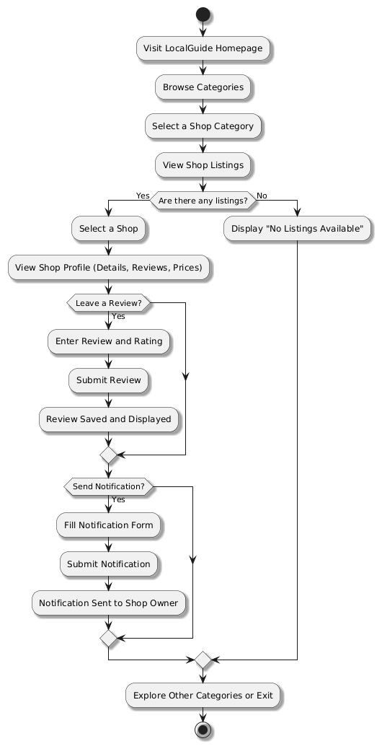

Fig 5.1 Flowchart representation of Local Guide

The flowchart for the *LocalGuide* project illustrates the step-by-step process of user interaction with the platform, from the homepage to detailed shop exploration and feedback submission. Here's a brief explanation:

1. **Visit LocalGuide Homepage**:  
   The user starts at the homepage, which acts as the central navigation hub.
2. **Browse Categories**:  
   Users browse the available categories, such as grocery, hardware, salon, etc.
3. **Select a Shop Category**:  
   After choosing a category, users are shown a list of shops belonging to that category.
4. **View Shop Listings**:  
   If shops are available in the selected category, their names, photos, and locations are displayed. If not, a message stating "No Listings Available" is shown.
5. **Select a Shop**:  
   Users can click on a specific shop to view its detailed profile.
6. **View Shop Profile**:  
   The shop profile includes details such as the shop's image, location, reviews, ratings, and a list of products with pricing.
7. **Leave a Review (Optional)**:  
   Users can provide feedback by entering a review and a rating. Once submitted, the review is saved and displayed on the shop profile.
8. **Send Notification (Optional)**:  
   If users have any queries, they can use the notification form to send a message directly to the shop. The form collects the query details and sends the notification to the shop owner.

**DFD of Local Guide:**

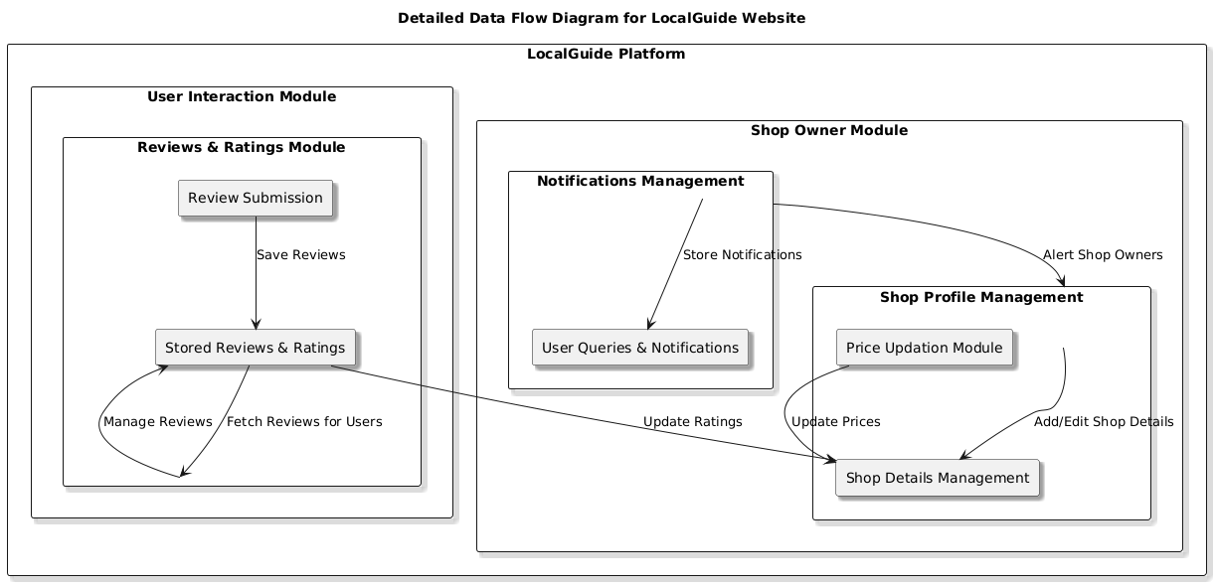

Fig 5.2 DFD representation of Local Guide

The provided Data Flow Diagram (DFD) outlines the architecture and information flow for the *LocalGuide* platform, highlighting its core modules and functionalities. Below is a brief explanation:

**1. User Interaction Module**

This module focuses on facilitating the interaction between users and the system.

* **Reviews & Ratings Module**:
  + Users can submit reviews and ratings for shops.
  + These inputs are stored in the "Stored Reviews & Ratings" component, which manages and fetches reviews for other users.
  + This feedback enhances user trust and helps others make informed decisions.

**2. Shop Owner Module**

This module allows shop owners to manage their shop profiles and respond to user queries.

* **Notifications Management**:
  + Handles user queries and sends notifications to shop owners.
  + Ensures that shop owners are alerted promptly about user concerns or questions.
* **Shop Profile Management**:
  + **Price Updation Module**:  
    Shop owners can update product prices to ensure accuracy and relevance.
  + **Shop Details Management**:  
    Enables shop owners to add or edit shop details, such as descriptions, locations, and contact information.

**3. Integration of Modules**

* The **User Interaction Module** and **Shop Owner Module** communicate seamlessly:
  + User reviews and ratings influence the shop's profile data.
  + Notifications ensure a direct link between users and shop owners for resolving queries and providing updates.

**Key Highlights**

* The diagram demonstrates a clear data flow between modules, ensuring a user-friendly experience for customers and efficient management tools for shop owners.
* Each module is designed to handle specific tasks, making the system modular, scalable, and easy to maintain.

This DFD captures the essence of the *LocalGuide* platform, emphasizing its focus on transparency, interaction, and usability.

**Chapter 6**

**Project Outcome**

The Local Guide project has successfully addressed the challenges of bridging the gap between consumers and local businesses by developing a centralized, user-friendly platform. This web application provides a comprehensive directory of local shops, including grocery stores, medical outlets, gyms, salons, hardware shops, and electronics stores. By offering detailed shop information such as location, contact details, ratings, and images, along with product catalogs and pricing, the platform enables users to make well-informed shopping decisions. Consumers benefit from the transparency and convenience of comparing product prices and shop reviews, saving them time and effort while fostering trust in the platform.

For small and medium-sized businesses, Local Guide serves as a powerful tool to increase their visibility and attract potential customers. It provides a digital presence for businesses that may lack access to advanced marketing resources, thereby leveling the playing field in the competitive local market. The platform promotes transparency and healthy competition among businesses, ultimately driving better service quality and pricing for consumers.

Additionally, the Local Guide enhances the shopping experience through intuitive features like category-based navigation, advanced search, and filtering options. By incorporating community-driven features such as user reviews and ratings, the platform fosters engagement and ensures continuous feedback for improvement. This project also highlights the value of modern web technologies in addressing real-world challenges, providing the development team with practical experience and innovative solutions.

With scalability as a core focus, Local Guide sets the stage for future enhancements such as personalized recommendations, e-commerce integration, and location-based services, ensuring its relevance and impact for years to come.

HOMEPAGE OF LOCAL GUIDE:

This is the main homepage of local-guide to provide the interaction with the platform to users. It has interactive and responsive interface and helps the users to engage with the website easily in accordance with their needs. It contains different sections to in which webpage is divided:

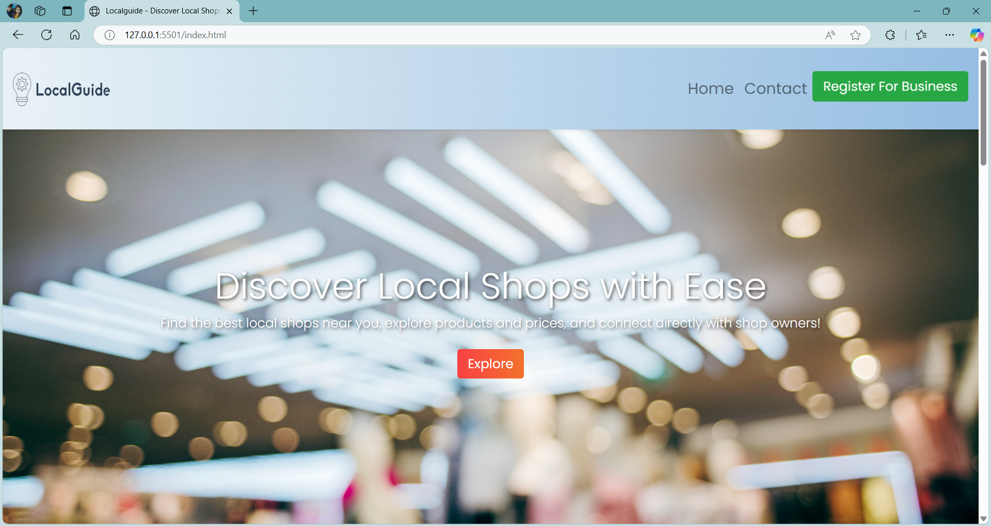

Fig 6.1 Homepage of Local Guide

In local Guide we have mainly 6 categories i.e Medical, Grocery, Electronics, Hardware, Salon, Gym. Inside all the categories we have all the shop listed according to the different categories.

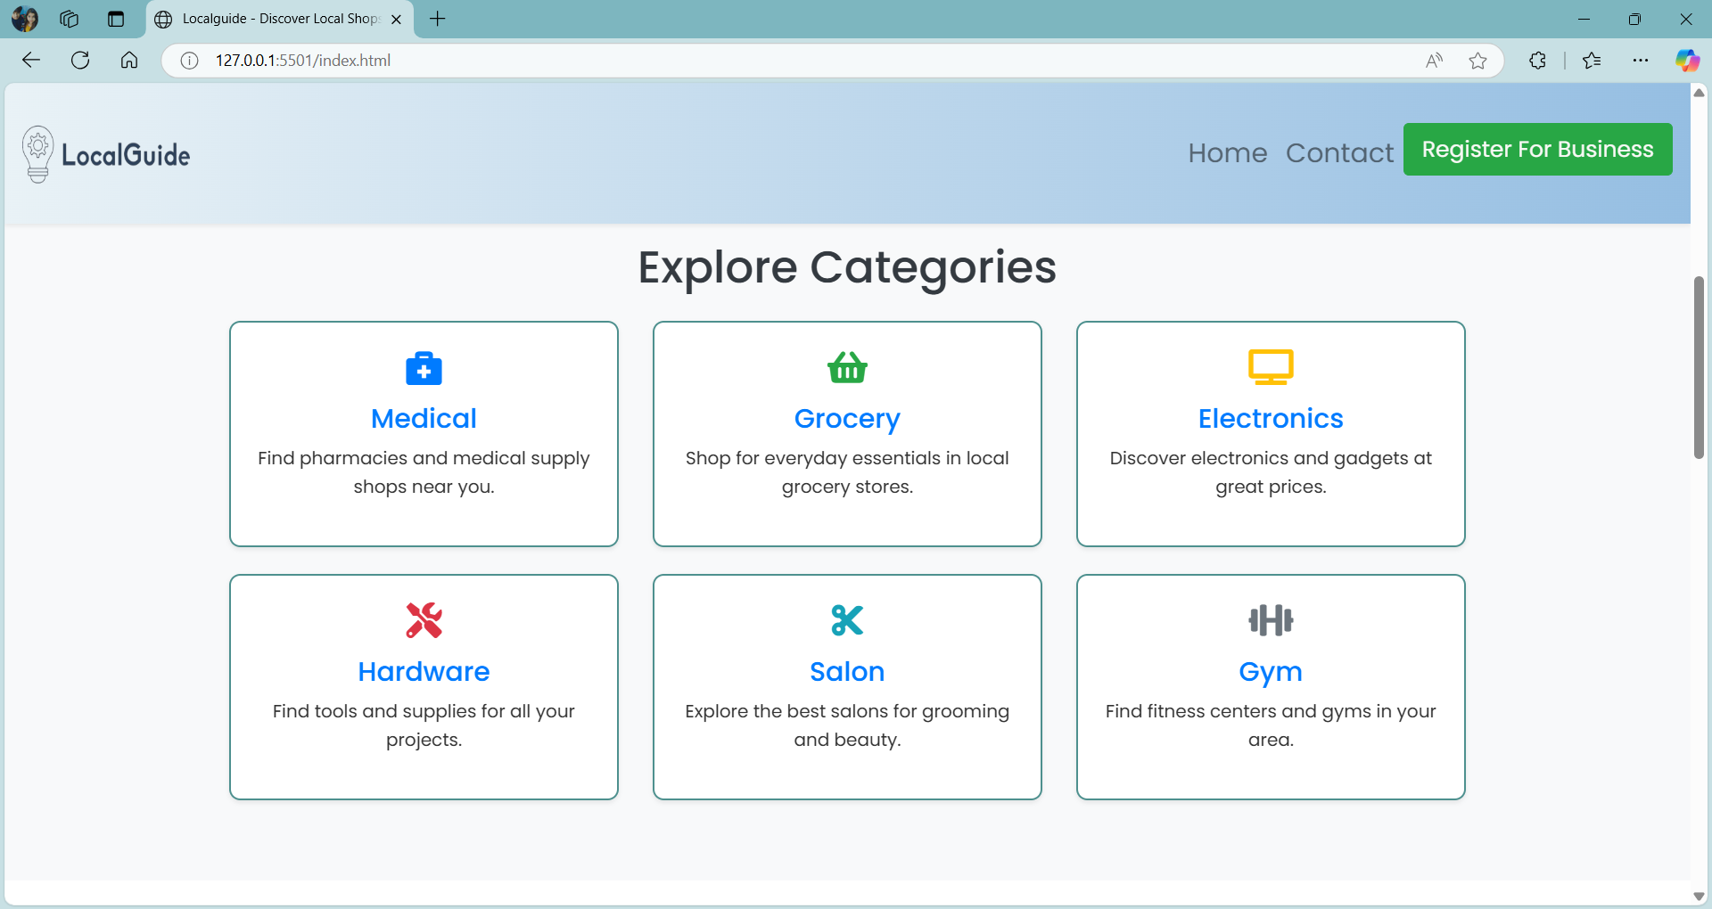

Fig 6.2 Categories section in home page

This is a why to choose us section which contains details of why LocalGuide better as compared to other websites. Our website is easy to use, it increases to grow revenue of the shop owners, fully privacy of your data is there and more other such features are there.

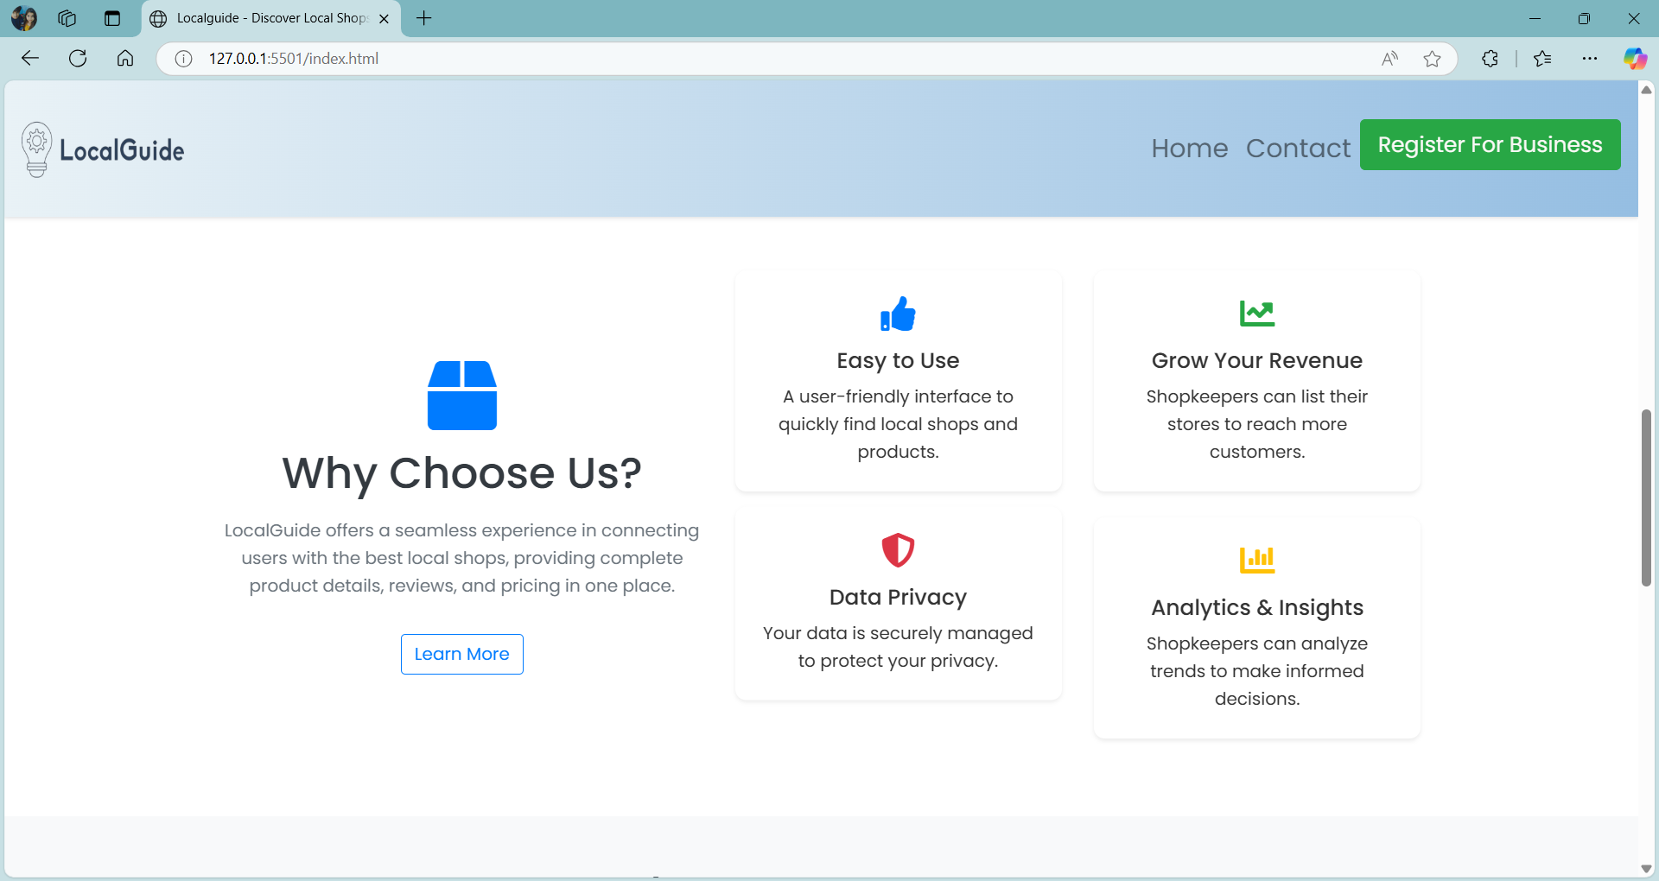

Fig 6.3 Why choose Us section.

Testimonial of our website: This is a testimonial section, in which there is a reviews from different users are listed at one place.

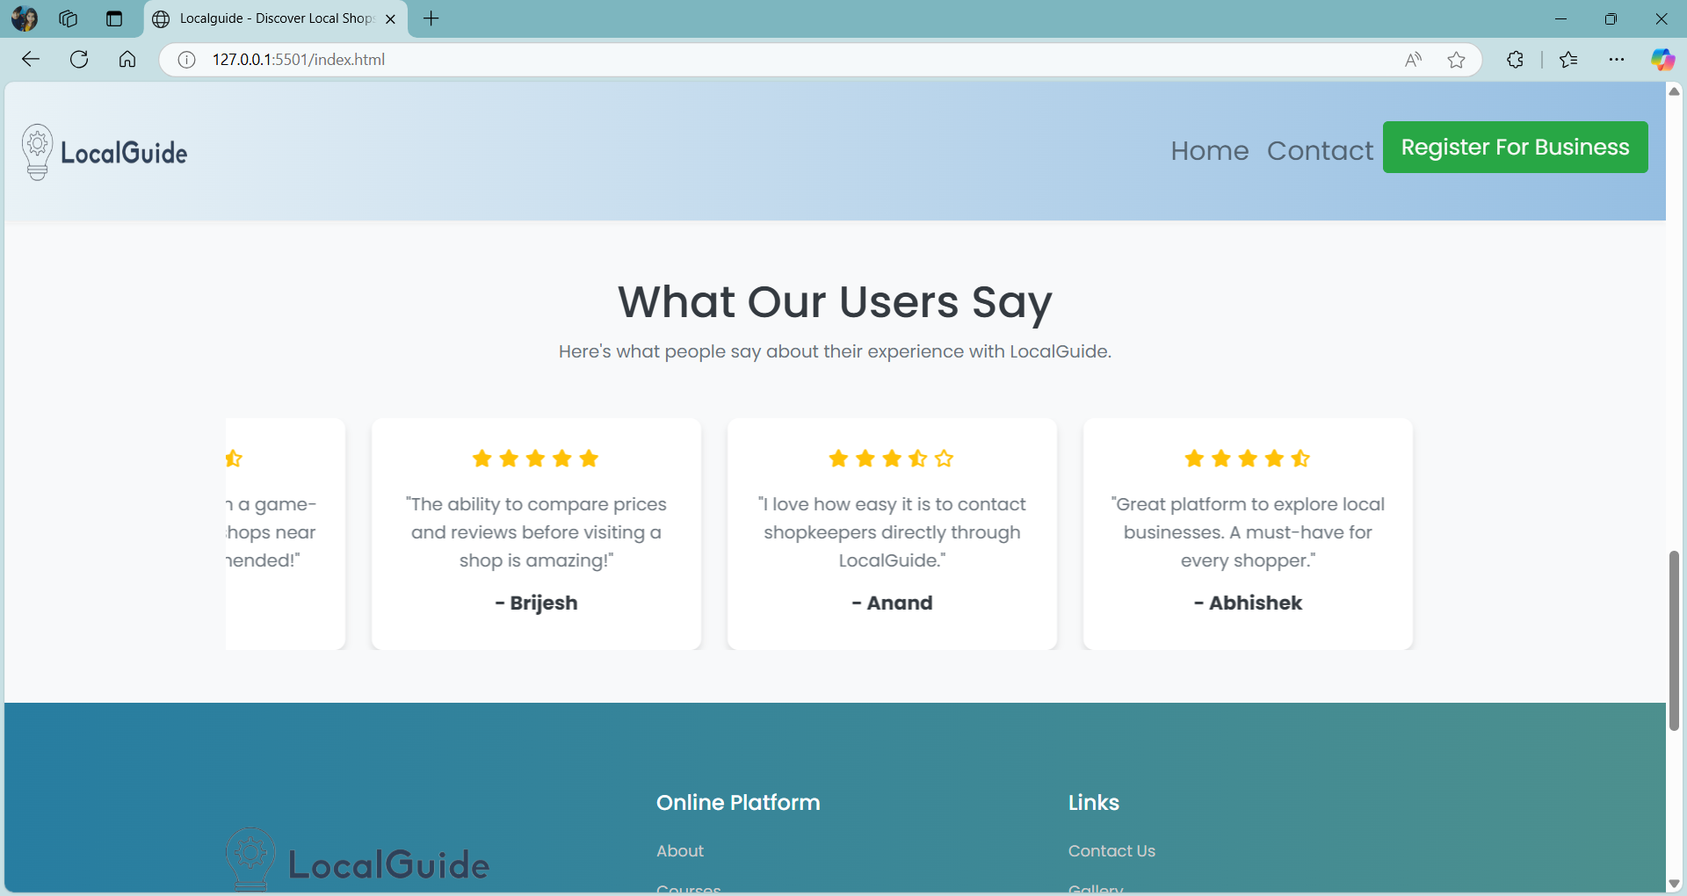

Fig 6.4 Testimonial Section

After Selecting Medical Category , it will show list of medical store and details with its name and location. Here all the medical shops of the particular location are listed and shown to you. You can select the required shop and find all the details about that shop inside inside that selected shop.

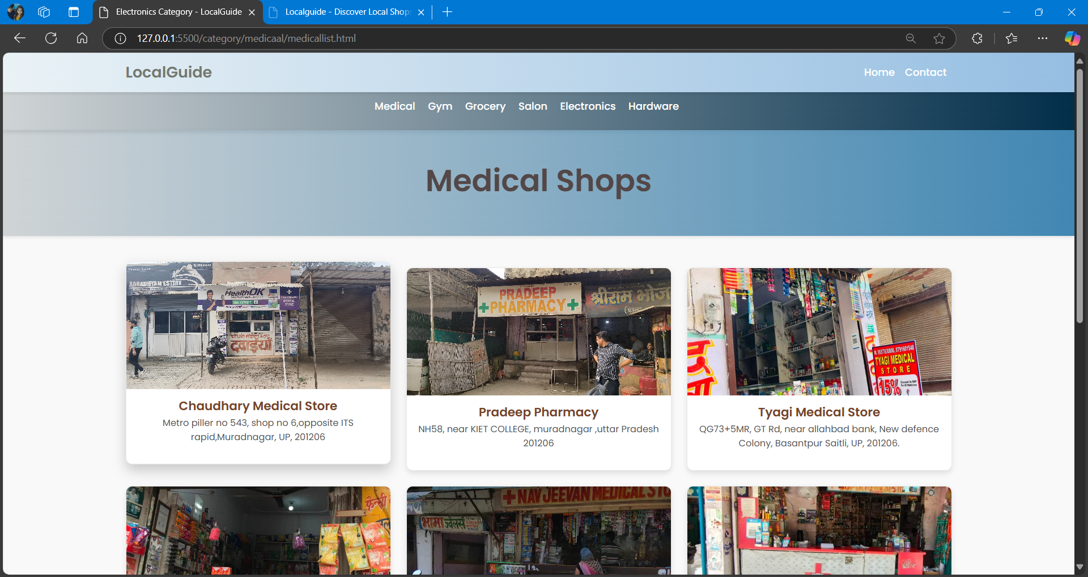

Fig 6.5 List of Medical stores.

After selecting that shop this window will be opening up in which all the details of that shop is mentioned. Here you will find details like about the shop, its location, some reviews from different users about that shop and you can also send your queries to the shop owner about your requirements on that section.

Example: Selected Chaudhary Medical store, it display shop’s photo and brief information of that shop.

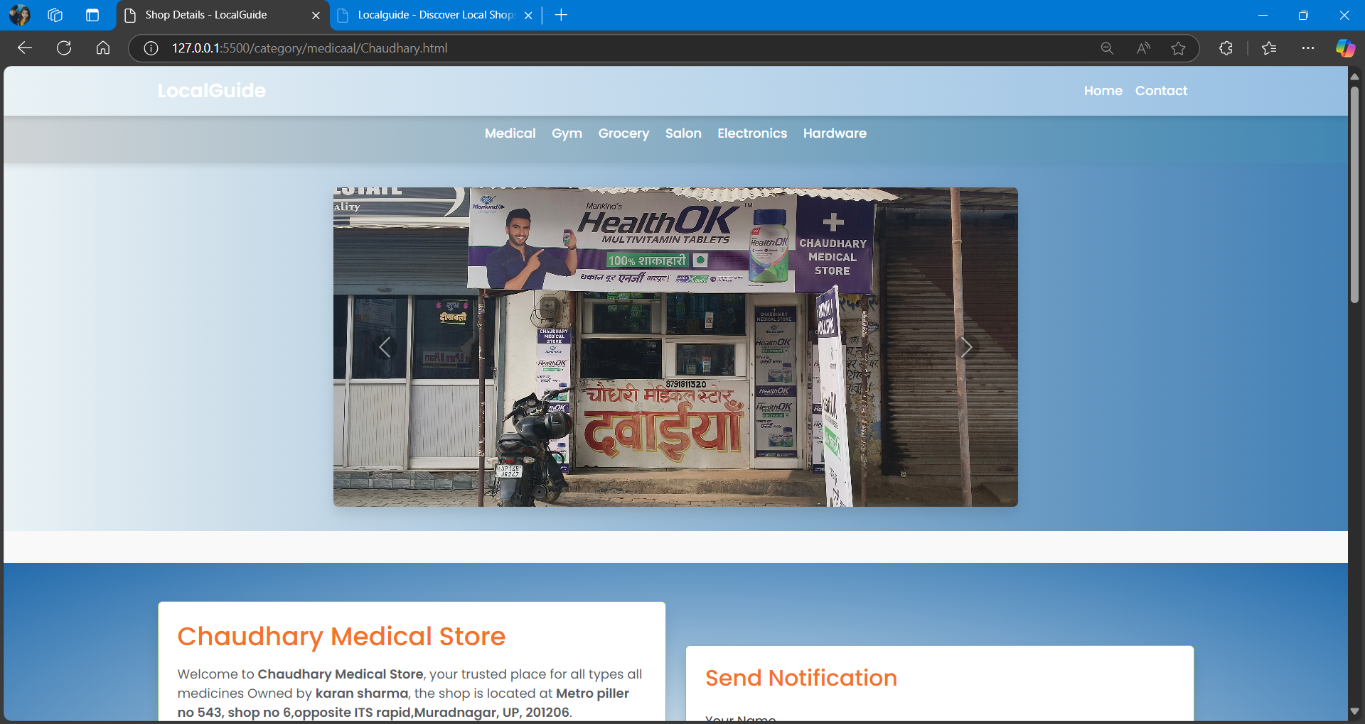

Fig 6.6 Subcategory of medical stores list( Chaudhary Medical store)

Section Like available product: It list products of that shop’s and also pricing to maintain user transparency .

Send Notification: This feature allows users to directly send queries or messages to the shop if they have any specific questions or concerns.

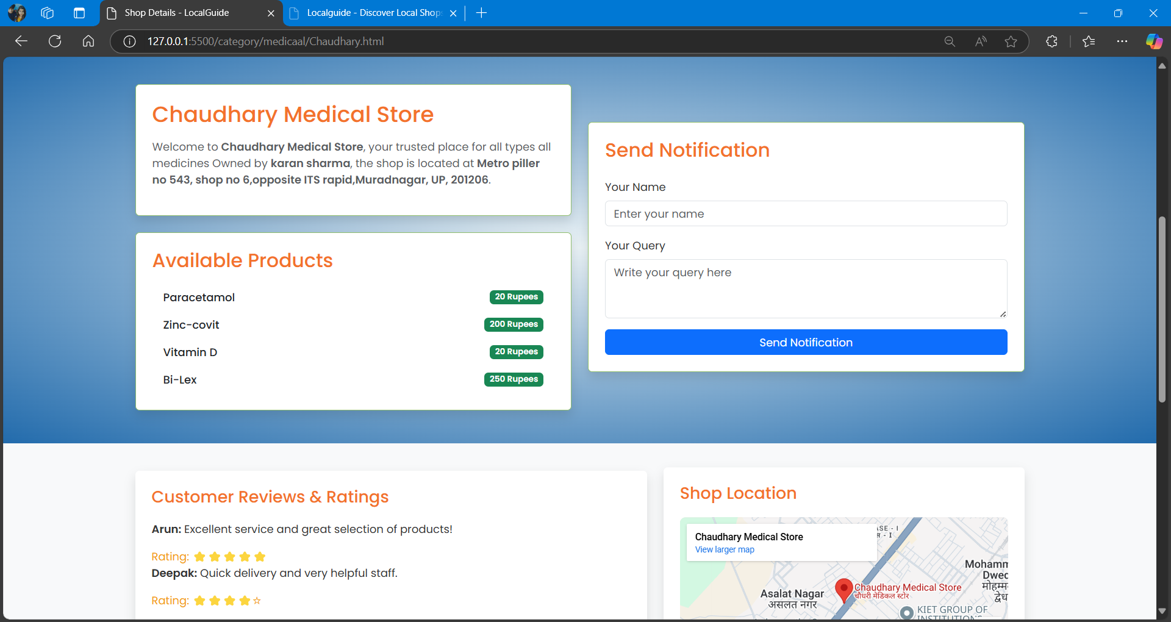

Fig 6.7 Within Chaudhary Medical Store ( about , available product in the store)

Customer Reviews and Rating section : ratings provided by other users, giving customers insights into the shop’s quality, customer service, and reliability.

Interactive Map Integration: A real-time map feature pinpoints the shop's exact location, offering convenience and aiding navigation for users who plan to visit.

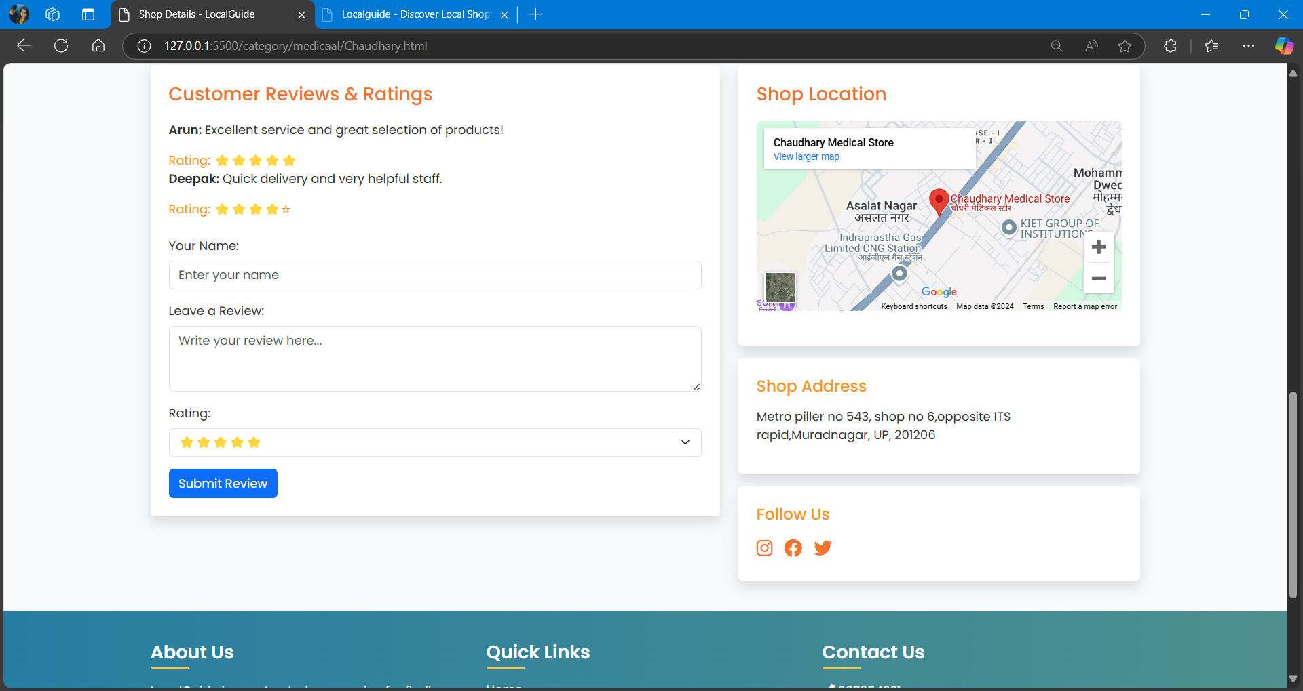

Fig 6.8 Within Chaudhary Medical Store ( Review section , google location of that store )

Selecting another category , for example GYM category, it will display like given below.

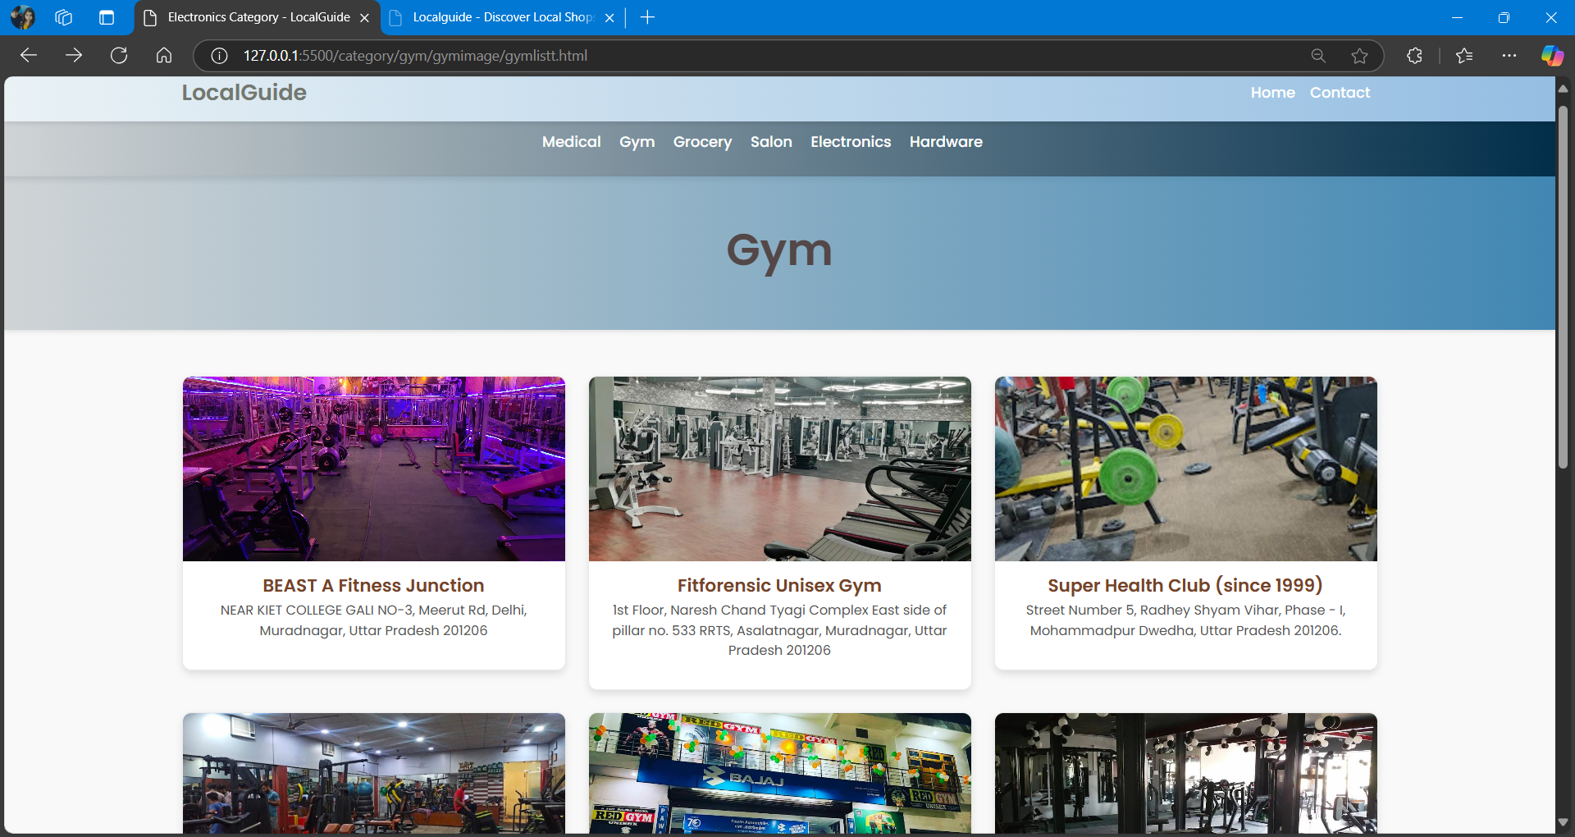

Fig 6.9 Gym Category Lists.

After Selecting beast gym, it display complete details about that gym.

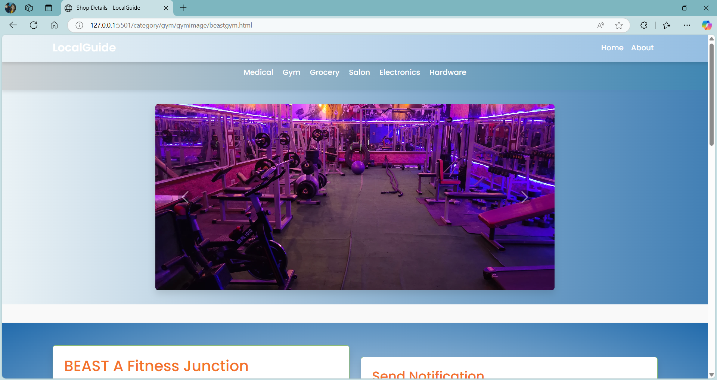

Fig 6.10 Subcategory of gym( selected Beast fitness junction gym)

Gym Membership pricing is listed in this section.

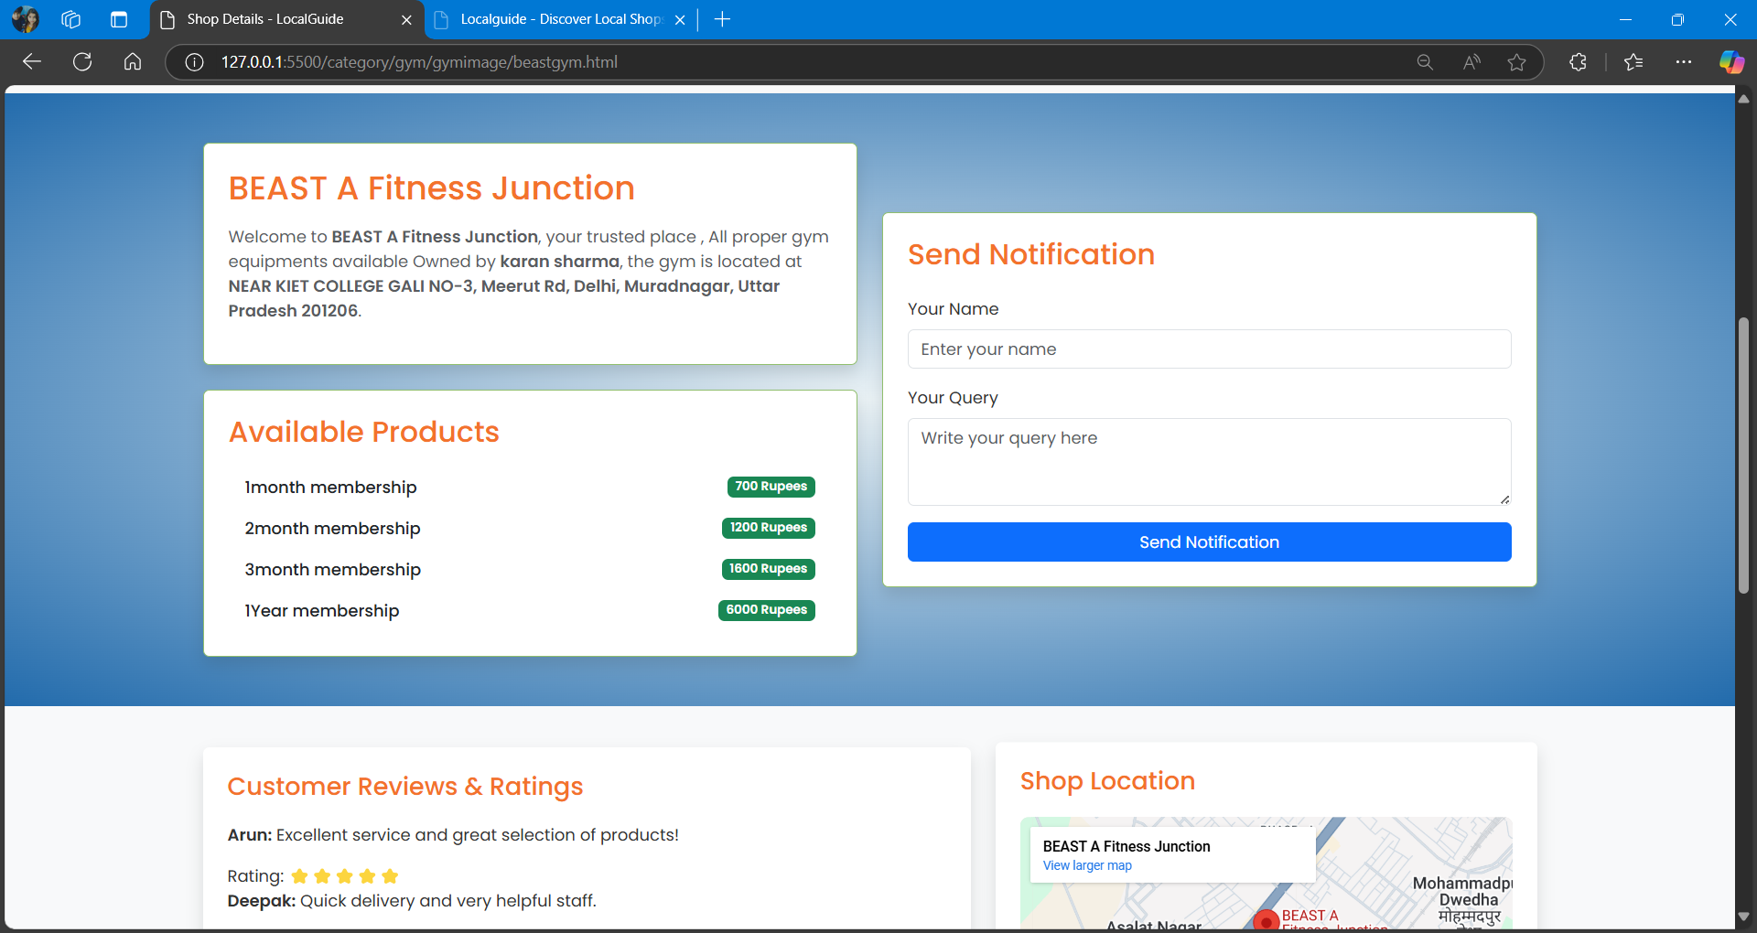

Fig 6.11 Within Beast Fitness Gym ( membership price section , about of that Gym )

**Shop owners Dashboard**

This is the shop owners dashboard from which shop owners will be able to manage all the activities related to their shops. They will be able to manage their shop though this dashboard. Shop owners will be able to list their shops, edit their shops (like they can add images, about the shop details), also they can add items names and prices.

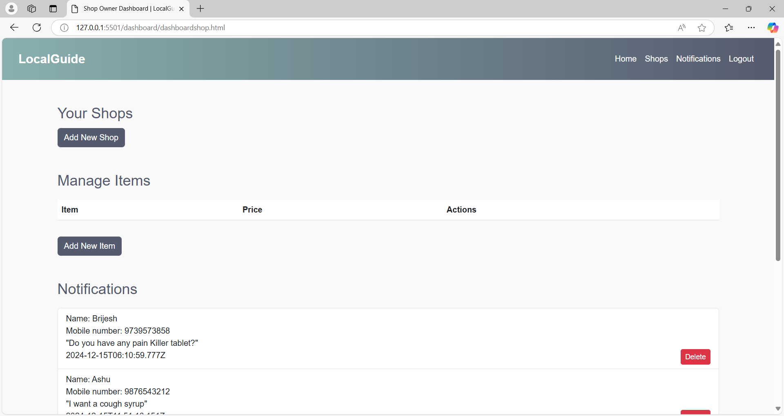

Fig 6.12 Dashboard of shop owners

Shop owners will also be able to see notifications of requirements from the users. These all notifications will be visible on their dashboard, where they will be able to manage them according to their requirements.

Also shop owners can add location of their shops directly from the dashboard and also they can edit it according to their needs.

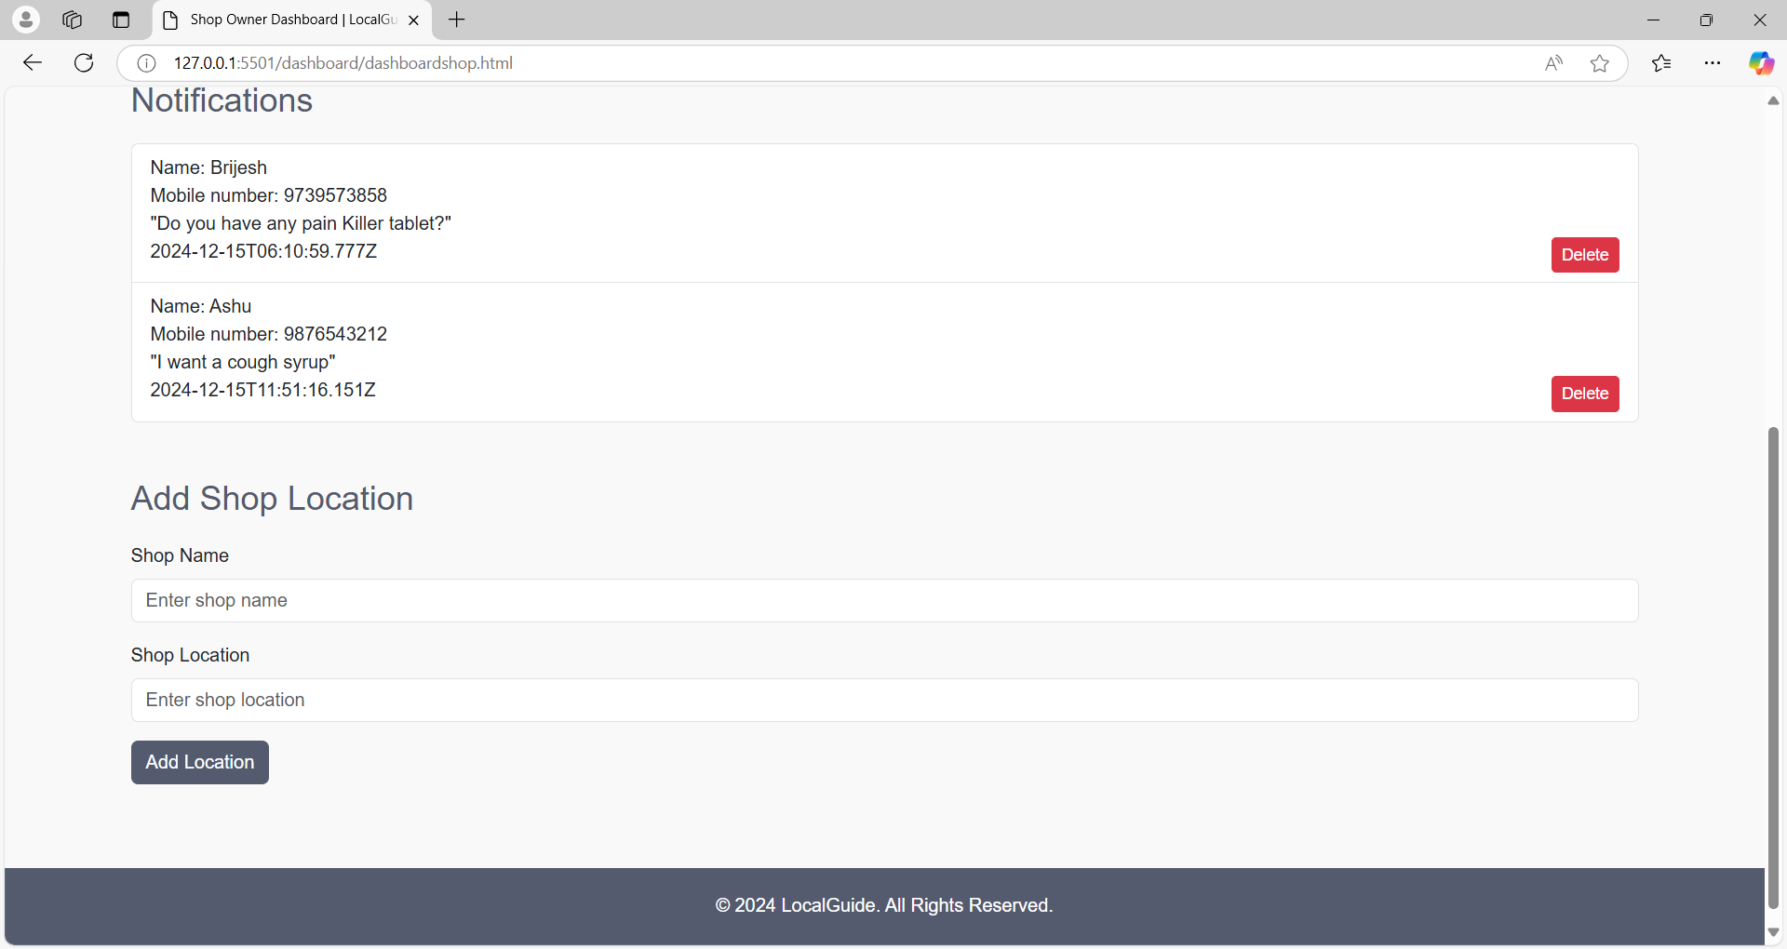

Fig 6.13 Dashboard of shop owners ( Notification section and add shop section)

**REFERENCES**

1. **Technologies Used**:
   * Bootstrap Documentation: https://getbootstrap.com/docs
   * Font Awesome: https://fontawesome.com
   * MySQL Documentation: <https://dev.mysql.com/doc>
2. **Tools and Frameworks**:
   * Node.js Documentation: https://nodejs.org/en/docs
   * Express.js Documentation: https://expressjs.com
   * Postman for API Testing: https://www.postman.com
   * Local commerce platforms and their integration with digital tools.